1.

17.72

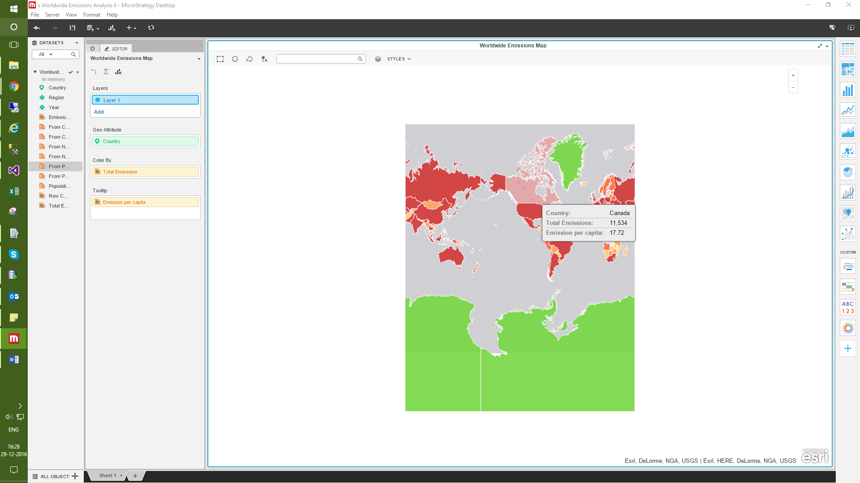

2.Total emission keeps on increasing from 1990 to 2008.In 2009 there is slight decreease in the emission but again increases in 2010.

3.The emission from all the three sources decreases in the year 2009